Appendix

Rhinovirus genotype | 2A Protease Recognition Site
 | DNA Seq | Amino Acid Seq
RV-A2 (minor) | ATTATCACTACAGCTGGCCCCAGT | IITTA*GPS
RV-B14 (major) | GTGACATTAAATCCTATGGTTTAGGACCTA | DIKSY*GLGP
RV-A16 (major) | AATCTAACAACTGTTGGGCCTAGTGACAT | NLTTV*GPSD

Table 1. Rhinovirus 2A protease recognition site. * The asterisk means 2A Protease cut site

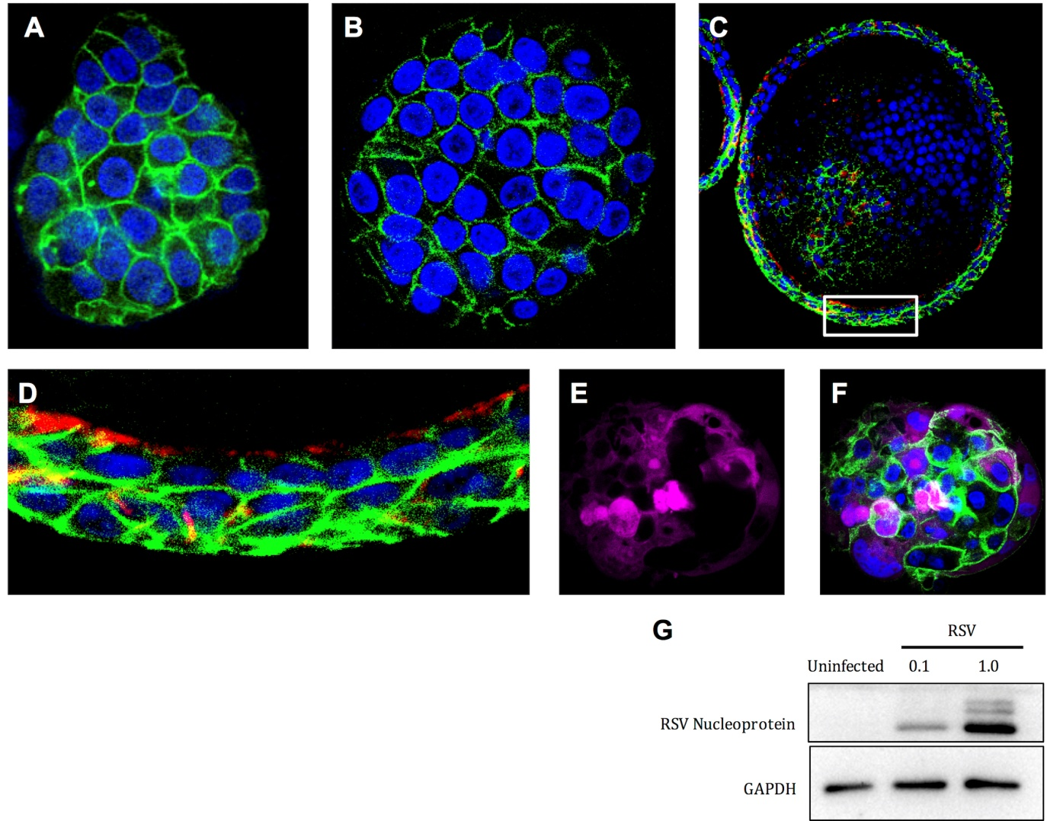
Figure 1. The 3D human airway spheroid model system. (A, B) Whole mount of 3D airway spheroids stained for membrane protein β-actenin in green and nucleus in blue. (C, D) A cross-section of the 3D airway spheroids stained for ciliated cell marker acetylated tubulin in red. (E, F) A 3D airway spheroids were infected with red florescent protein (RFP)-RSV at a MOI of 1, the whole spheroid was fixed at 3 days post-infection and RSV-infected cells was in magenta. (G) 3D airway spheroids were left uninfected or infected with RSV at multiplicity of infection of 0.1 and 1.0. Whole spheroid extracts were prepared at 48 hours post-infection and analyzed by western blotting. RSV infection was confirmed by the presence of RSV nucleoprotein. GAPDH was used as loading control.
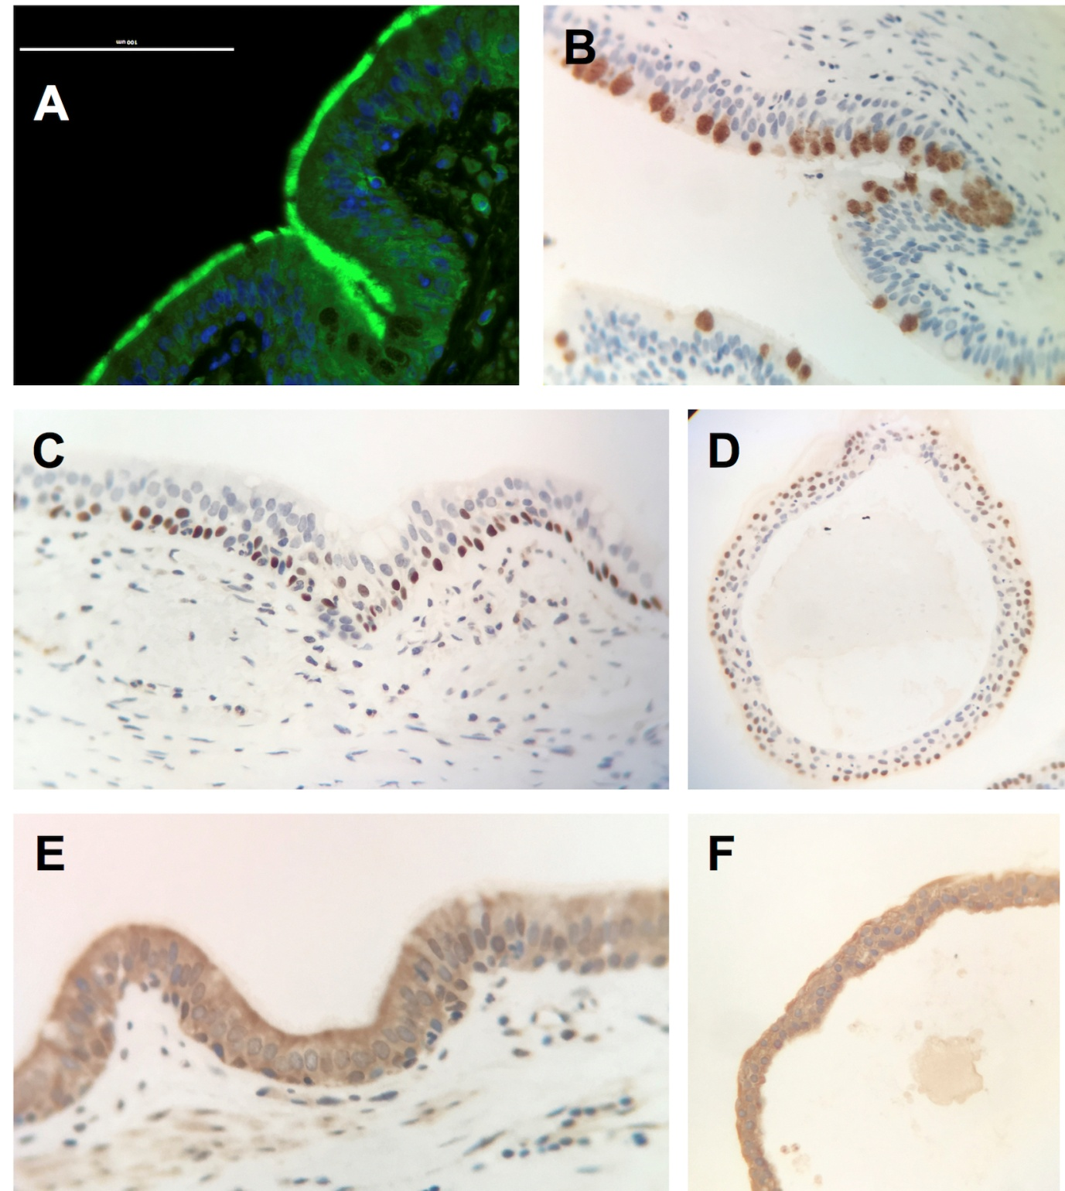

Figure 2. The human respiratory epithelial models. (A) Human bronchial explant culture expresses ciliated cell stained in green by β-tubulin antibody and (B) goblet cell stained in reddish brown by MUC5AC antibody. (C,E) Human bronchial explant culture and (D,F) the 3D airway spheroid stained with (C,D) basal cell using p63 antibody and (E,F) the distribution of rhinovirus C receptor using CDHR3 antibody in reddish brown.
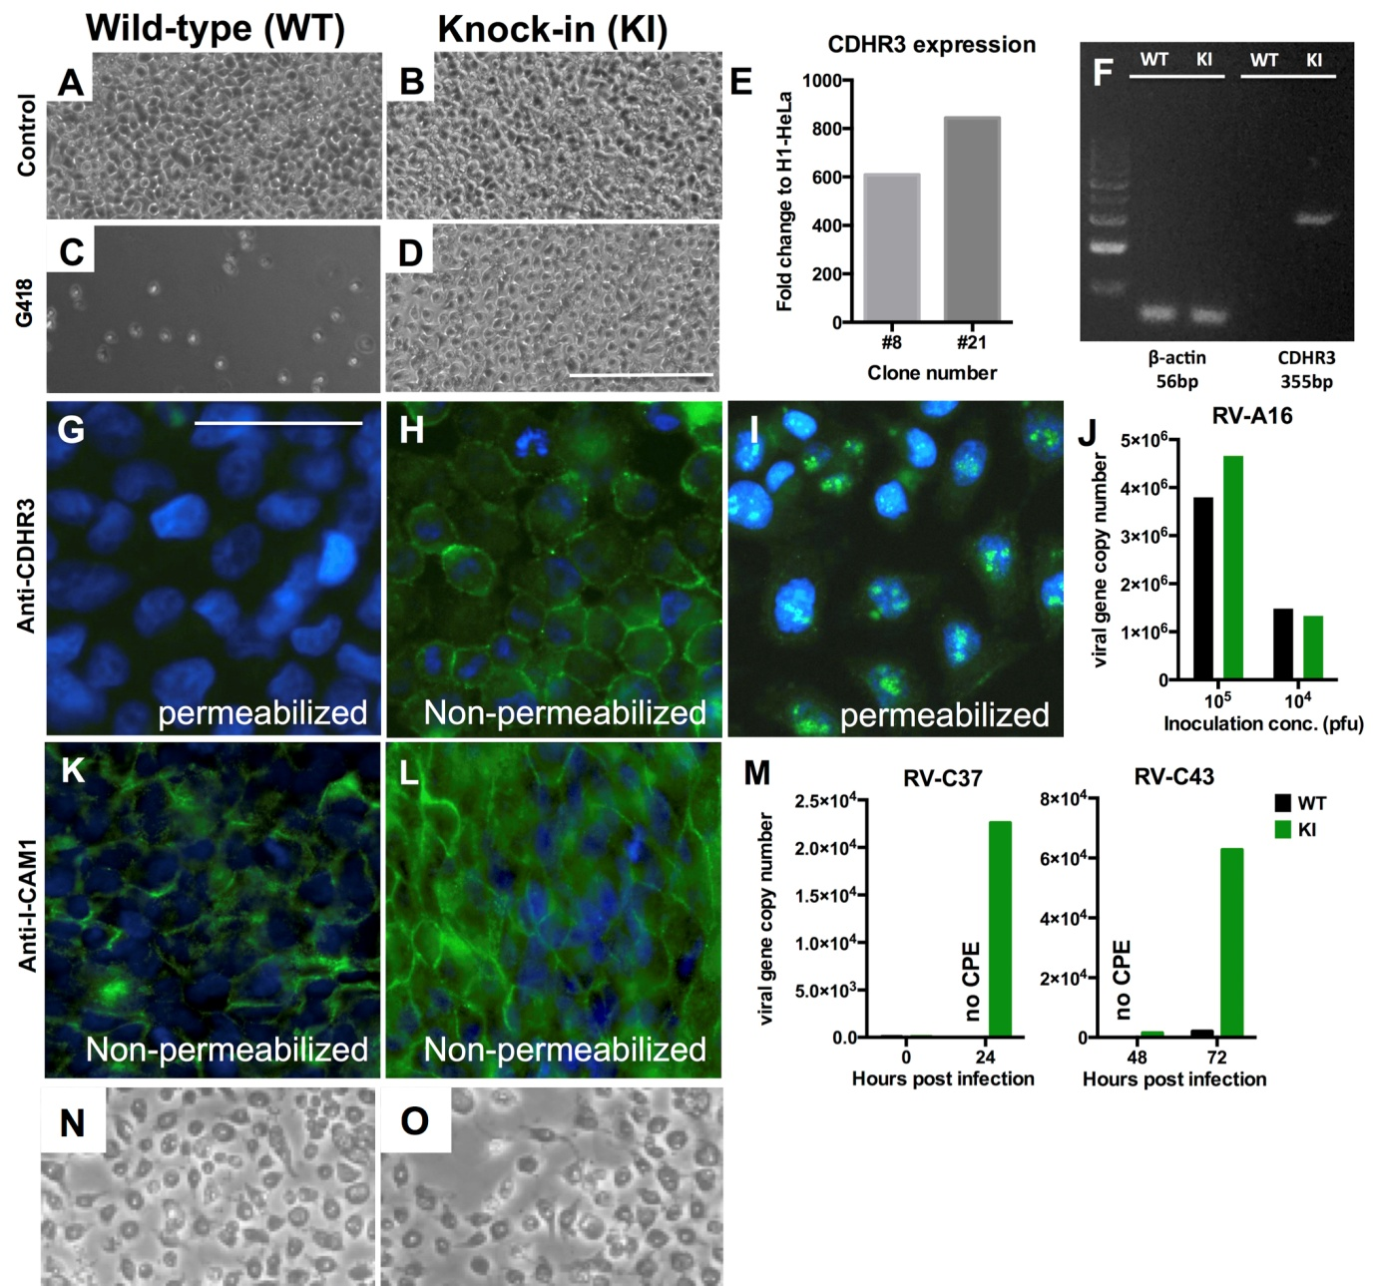

Figure 3. Construction of CDHR3_{529Y} expressing H1-HeLa cells. (A) H1-HeLa (ATCC, CRL-1958) was purchased directly from ATCC. (B) Plasmid expressing human CDHR3 was purchased (Origene, RC218636) and mutated CDHR3_{529Y} was engineered by point mutation using Q5® site directed mutagenesis Kit (E0554S, New England Biolabs) and validated by sanger sequencing. Lipofectamine 2000 was used to transfect into H1-HeLa cell and CDHR3_{529Y} expressing cell was selected using G418. (C) Wild-type H1-HeLa was killed by G418 while (D) the survived cells were seeded onto a 96-well plate for clonal expansion. (Scale bar, 200μm) (E) Several clones were selected and the expression of CDHR3 of each clone was determined by qPCR. With the highest CDHR3 expression, clone #21 was selected for subsequent experiments. (F) Electrophoresis was performed to confirm the expression is at specific size. (G-I) The successful knock in of the CDHR3 protein was examined for their cellular localization by immunofluorescence assay using anti-CDHR3 antibody (HPA011218, Sigma) and counterstained with DAPI. (Scale bar, 50μm) (G) WT H1-HeLa expressed no CDHR3 as indicated, while KI H1-HeLa expressed CDHR3 (H) on the surface and (I) at the nucleoli. (J) WT (black) and KI (green) both supports the replication of control RV-A16 strain to replicate with two different dilution of virus inoculations. (K-L) The normal expression of ICAM-1 was maintained in (L) WT and (K) KI H1-HeLa cell by using anti-ICAM-1 antibody (HPA002126, Sigma) and counterstained with DAPI. (M) An experiment using nasopharyngeal aspirate specimen of RV-C37 and RV-C43 genotypes indicated that a significant increase in viral gene copy number in the supernatant of the inoculated KI H1-HeLa (green bars) with (N-O) cytopathic effect but not in that of the WT H1-HeLa culture (black bar).

